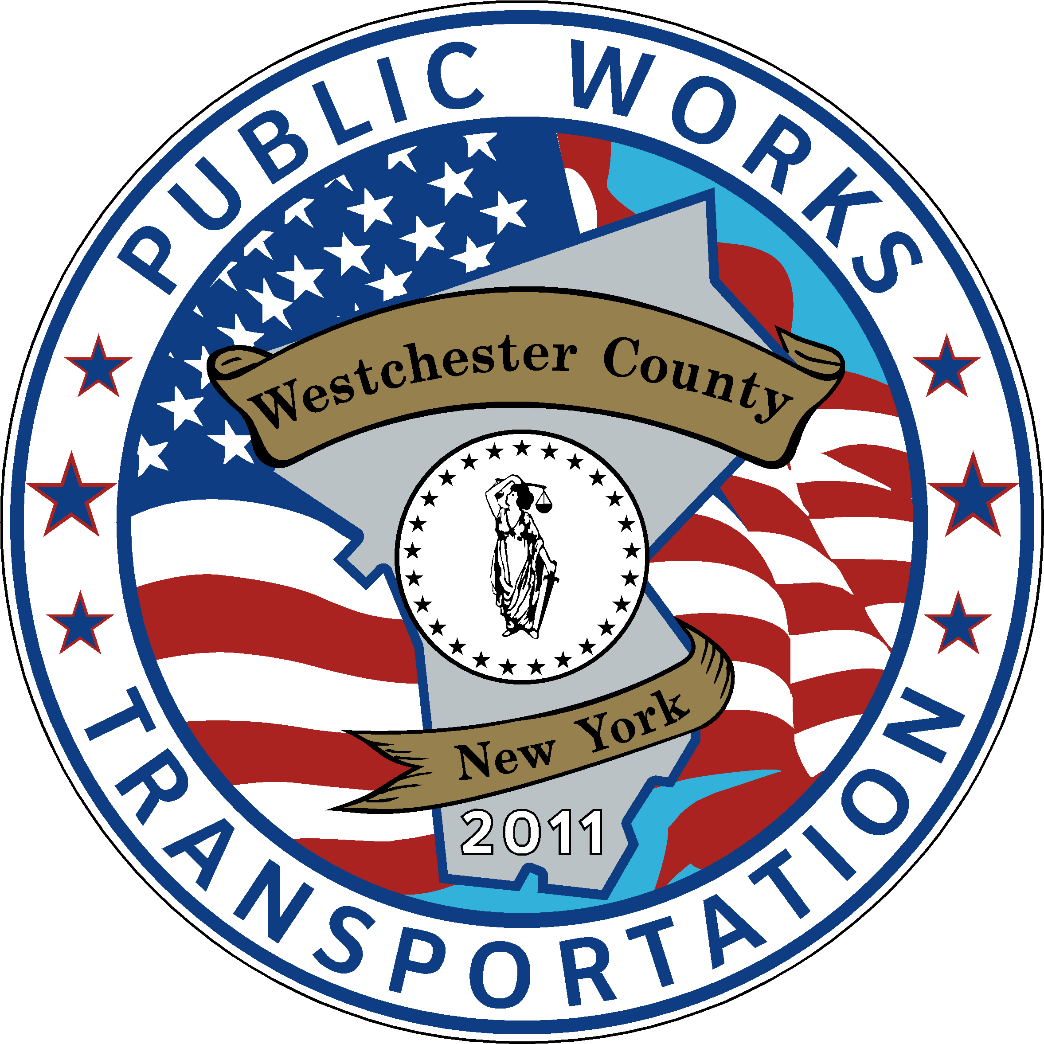

Invoice Number: 2022-10-YPS
Invoice Date: 10/24/22

Bill to: Yonkers Public Schools
ATTN: Jinjuta Phothipraisiri

1-Trip MetroCard –30,000 qty

30,000 @ $2.75 ea. $82,500.00

Balance Due $82,500.00

Terms: Payment due upon receipt



