
Goodheart-Willcox Publisher
18604 West Creek Drive • Tinley Park, IL 60477-6243 Orders 1-800-323-0440
www.g-w.com • custserv@g-w.com Phone 1-708-687-5000
Fax 1-708-687-5068

Re: Sole Source Vendor Information

The Goodheart-Willcox Company is the publisher, copyright holder and sole source of the materials listed in our Family and Consumer Sciences, Technical/Trade/Engineering, Business, Marketing, Career Education, and Automotive Education, Agricultural Education and Health Sciences catalogs with the exception of the following:

Family and Consumer Sciences Catalog |  |  | Technical, Trades, Technology Catalog
ISBN | Title |  | ISBN | Title
9780846100010 | THEMES IN FCS: READINGS (2004) |  | 7169 | SUCCESSFUL CAMERA VIDEO (2004)
9780846100041 | FAMILY COMMUNITY POLICY (2004) |  | 7170 | SUCCESSFUL LIGHTING VDO (2004)
9780846100058 | AAFCS FOOD HANDBOOK (2006) |  | 7171 | SUCCESSFUL SOUND - VIDEO (2004)
1571758062 | CHILD DEVELOPMENT THEORISTS (2009) |  | 7172 | SUCCESSFUL EDITING VIDEO (2004)
9781571752366 | IT’S YOUR MONEY: FINANCIAL FLIGHT SCHOOL |  | 10789 | HOW TO PRODUCE A VIDEO (2004)
P173 | AGE APPROPRIATE PLAY SET OF 3 2002) |  | 30627 | SUCCESSFUL NON-LINEAR ED (2004)
 |  |  | 4665D | AUTO BODY REPAIR BASICS (2004)
 |  |  | 4673D | AUTO CONSTRICTION (2004)
 |  |  | 4681D | WELDING (2004)
 |  |  | 469XD | SHEET METAL REPAIR-DINGS AND SCRATCHES
 |  |  | 4703D | REPLACING & ADJUSTING PANELS (2004)
 |  |  | 4711D | STRUCTURAL ANALYSIS & DAMAGE REPAIR
 |  |  | 472XD | BODY ALIGNMENT (2004
 |  |  | 4738D | PLASTICS & ADHESIVES (2004)
 |  |  | 4746D | ELECTRICAL REPAIRS (2004)
 |  |  | 4754D | BRAKING SYSTEM REPAIR (2004)
 |  |  | 4762D | SURFACE PREPARATION & REFINISHING
 |  |  | 4789D | MISCELLANEOUS REPAIRS (2004)
 |  |  | 4800D | AUTO BODY REPAIR DVD SERIES SET OF 12

We appreciate your interest in our products. If there is anything else you need, please contact us at 800-323-0440.

Sincerely,
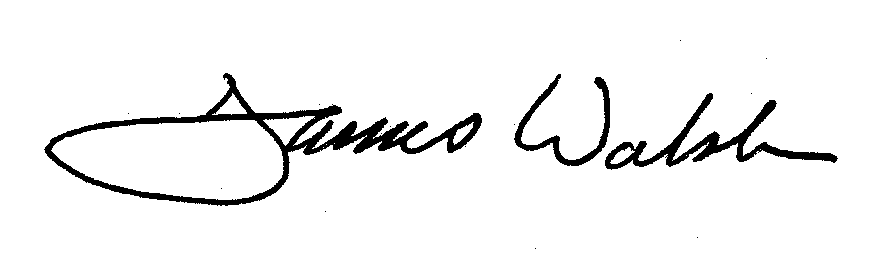
James Walsh
National Sales Manager

