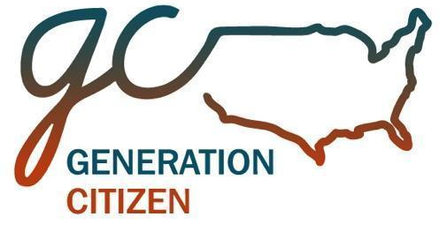
ACTION CIVICS PARTNERSHIP TIMELINE
YEAR 1

Over the course of the semester, GC staff work closely with school and district leaders to build a comprehensive action civics program. The first year of a partnership includes the supports listed below.

BEFORE SEMESTER
Partnership Planning and Strategy
Setting a Calendar for Action Civics
Introducing Action Civics to Your Community
Hosting a Local Civics Day Celebration
Communications, Procedures and Logistics

EARLY SEMESTER

Initial Full-Day Professional Development
Understanding the Action Civics Approach
The Advocacy Hourglass Framework for Action
Action Research for Political Change
Mapping Local Government
Assessing Action Civics
Communications, Supports and Logistics

Coaching Session One
Review Local Article Research
Create Guest Speaker Call Plan
Present Action Project Goal Ideas
Review Unit 2: Action Research Unit
Self-Assessment Classroom Rubric

MID SEMESTER

Mid-Semester Half-Day Professional Development
Strategic Targets and Tactics
Project Organization and Tracking
Structuring Group Work for Student Action

Coaching Session Two
Making Group Work Effective
Feedback on Class Specific Action Plans
Preparing Students for Public Presentations
Self-Assessment Classroom Rubric

END OF SEMESTER

Statewide Civics Day
Each GC class sends a delegation of student representatives to present their advocacy project to elected officials and local leaders.

School/District Civics Day
Schools or districts host a local showcase of student advocacy projects and invite other students, community members, parents and local leaders to celebrate their work.

Partnership Review and Planning
Teachers and administrators meet with GC staff to review outcomes and determine priorities and logistics for the upcoming partnership year.

